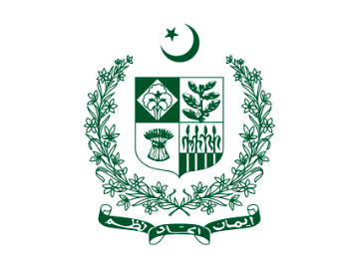

Committee: Security Council
Topic: The Situation in Afghanistan
Delegate: Mariana Ramírez Cabal
Delegation: Islamic Republic of Pakistan

Greetings Honorable Chair, Fellow Delegates, and others present in the room,

The committee of the Security Council has gathered here today to discuss and conceivably agree
upon a topic of utmost relevance presently. It is known by every delegate in the committee that
at the outset, the situation in Afghanistan will be debated and is in need of urgent solving.

For starters, one could describe the fact that the delegation of Pakistan has found itself implicated
in the Afghan conflict as utile, as it comes to show the need for international cooperation in order
to establish peace.

Pakistan believes that ever since it was necessary, it has helped the right side of the conflict and
does not appreciate other delegations alluding otherwise.

Thank you for your time and attention.
Pakistan Zindabad.

